Ex.No:9
Date:
Data Flow Diagram

Aim:
To design and visually map the high-level data flow and modular architecture of an Online Food Ordering System, ensuring clear separation of concerns between core processing, management functions, and data storage.

Problem Description:
Modern food delivery platforms must handle complex, concurrent processes including user registration, menu updates, and order tracking. The problem is how to design a centralized system that effectively coordinates these distinct operational areas (Customers, Orders, Food items, Categories, and System Users) without creating a tangled, unmanageable architecture, while ensuring that the data for each domain is securely and independently stored.

Given Conditions / Constraints:
Based on the visual representation, the system operates under the following design constraints:
- Centralized Orchestration: All data and processes must route through the central "Online Food Ordering System" core. Peripheral modules do not communicate directly with one another.
- Data Segregation: Information cannot be pooled into a single, massive database. It must be compartmentalized into specific, dedicated data stores (Food DB, Category DB, Order DB, Customer DB, User DB).
- Role Separation: There must be a strict boundary between front-end consumers ("Customer Management") and back-end administrators/staff ("System User Management").
- Bidirectional Flow: The system must be capable of both sending requests to and receiving responses from its management modules and databases (indicated by the two-way arrows).

Approach / Methodology:
The approach utilizes a Modular Data Flow architecture (resembling a Level-0/Level-1 DFD).
- Star Topology: The methodology employs a central hub-and-spoke model where the core application acts as the primary controller.
- Database-per-Domain: It implicitly follows a microservices or highly structured monolithic methodology by aligning specific management logic (e.g., Order Management) with its corresponding data domain (Order DB).

Planning and Estimation:
From a project management perspective, this diagram sets the stage for phased development:
- Phase 1 (Data Layer): Provisioning and designing schemas for the five distinct databases.
- Phase 2 (Core Layer): Developing the central routing and API gateway (the central circle).
- Phase 3 (Service Layer): Parallel development of the five management modules, which can be estimated and assigned to different developers independently due to the modular design.

Scheduling / Design Considerations:
- Design Consideration: The central node will be a high-traffic bottleneck. A major design consideration is ensuring this central routing system is highly available and capable of handling concurrent requests without latency.
- API Design: Standardized APIs or communication protocols (like REST or gRPC) must be designed for the bidirectional arrows to ensure smooth data transfer between the central system and the outer nodes.
- Scheduling: Because the modules are independent, their development can be scheduled concurrently, reducing overall time-to-market.
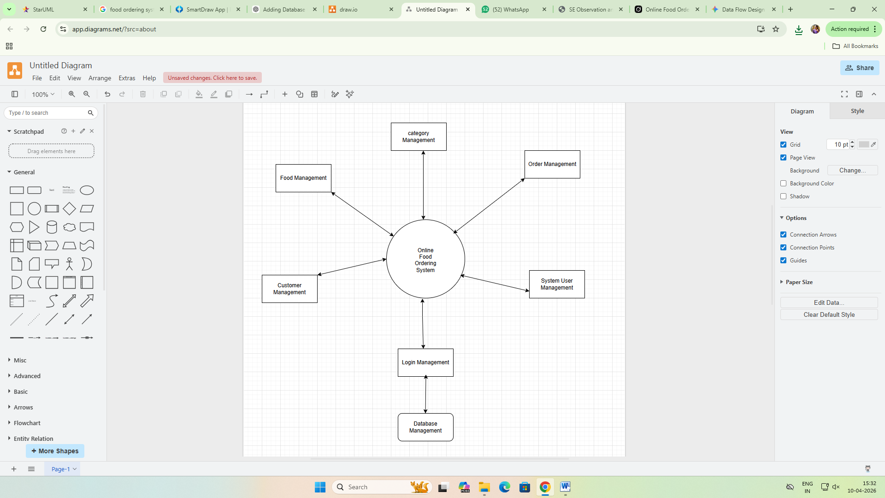

Feasibility Analysis:
- Technical Feasibility: High. The architecture is standard and highly practical. Separating databases and management modules is a proven industry standard for e-commerce, making it easy to implement using standard relational (SQL) or non-relational (NoSQL) database technologies.
- Operational Feasibility: High. This structure allows a business to divide its operational teams logically (e.g., one team handles the Food/Category catalog, another handles Customer Support and Orders).

Result:
The result is a clear, comprehensive architectural blueprint. It successfully identifies all necessary actors, processes, and data repositories required to build a functional food ordering platform, outlining exactly how data will flow from user inputs to final database storage.

Conclusion:
The proposed Data Flow Diagram provides a robust and scalable foundation for the Online Food Ordering System. By centralizing the core logic while decentralizing the management functions and databases, the design achieves high modularity, easier maintainability, and enhanced security (specifically by separating Customer data from internal System User data). It serves as an excellent starting point for transitioning into lower-level technical design and coding.

